Assignment 2:
Write a react js code that will render the following
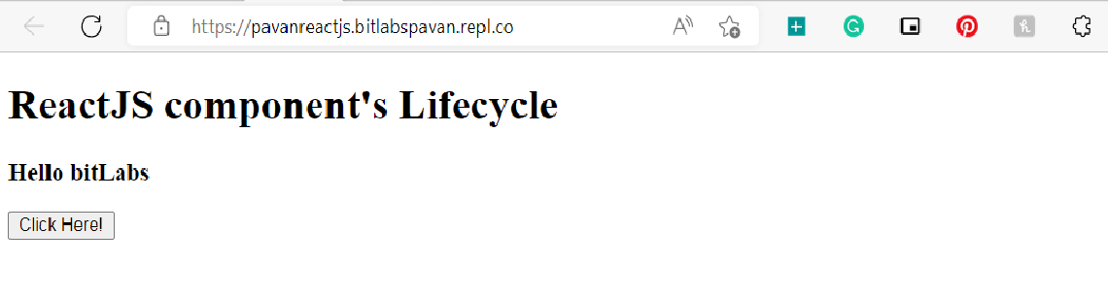When you click on the Click Here Button, you get the updated result which is shown in the below screen

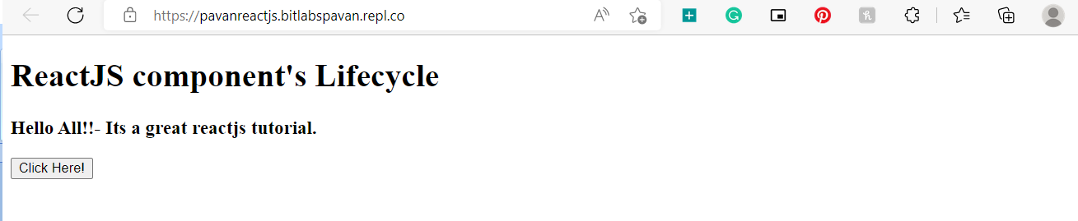
During rendering, write appropriate messages to the console using the lifecycle’s methods

Ans:
import React, { Component } from 'react';

class App extends React.Component
{
constructor(props)
{
super(props);
this.state = {hello: "bitLabs"};
this.changeState = this.changeState.bind(this)
}
render()
{
return(
<div>
<h1>ReactJS component's Lifecycle</h1>
<h3>Hello {this.state.hello}</h3>
<button onClick = {this.changeState}>Click Here!</button>
</div>
);
}
componentWillMount()
{
console.log('Component Will MOUNT!')
}

componentDidMount()
{
console.log('Component Did MOUNT!')
}
changeState()
{
this.setState({hello:"All!!- Its a great reactjs tutorial."});
}
componentWillReceiveProps(newProps)
{
console.log('Component Will Recieve Props!')
}
shouldComponentUpdate(newProps, newState)
{
return true;
}
componentWillUpdate(nextProps, nextState)
{
console.log('Component Will UPDATE!');
}
componentDidUpdate(prevProps, prevState)
{
console.log('Component Did UPDATE!')
}
componentWillUnmount()
{
console.log('Component Will UNMOUNT!')
}
}
export default App;

